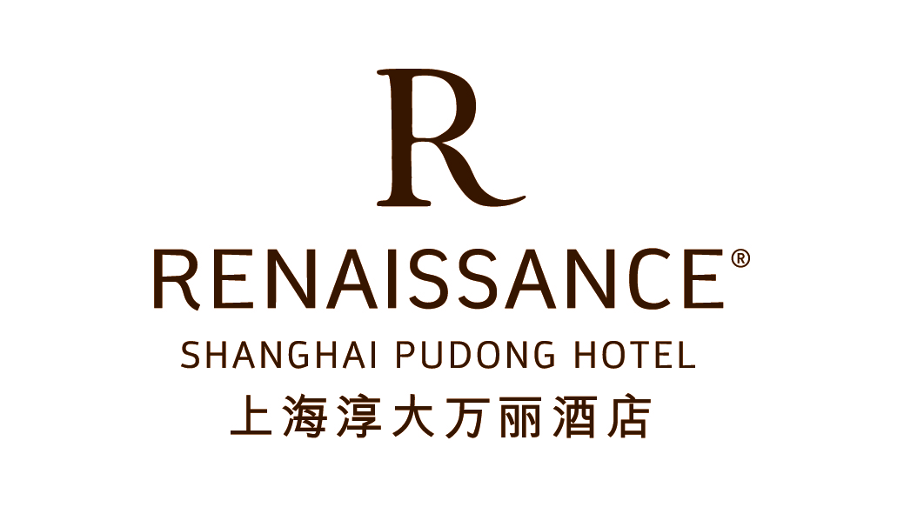

eChinaChem,Inc.
November 01 - 05, 2015(Block code: CC2)

Please complete this Reservation Form and send it to the Reservations Department
E-mail to rhi.sharn.reservations@renaissancehotels.com Fax No: 86-21-38714886

Guest Name (Mr. / Ms. / Mrs) ____________________________________________________________________
Circle one Last Name First Name

Telephone _____________________________________
Country code / area code / number

Fax ___________________________________________ Email ___________________________________
Country code / area code / number

ARRIVAL DATE ____________________________ DEPARTURE DATE ________________________________

Room Type
€ Deluxe Room with one King Bed € Smoking € Non smoking
€ Deluxe Room with two Single Beds € Smoking € Non smoking
(Room type request will be arranged subject to hotel room availability)

Conference Rate
- Deluxe Room with one King Bed RMB980 and subject to 15% service charge, inclusive of one breakfast.
- Deluxe Room with two Single Beds RMB1080 and subject to 15% service charge, inclusive of two breakfast.

  - To ensure that room space is available, please make your reservation before September 14, 2015. After the date any confirmation of the room will be subject to our hotel availability.
  - Hotel check-in: 14:00/ Check-out:12:00.

Special Requests ________________________________________________________________________

Flight/Transfer

ARRIVAL FLIGHT / TIME _________________________ DEPARTURE FLIGHT / TIME_____________________
  - Limousine pick up from Hongqiao / Pudong Airport at RMB750. € Yes € No
  - Limousine drop off to Hongqiao / Pudong Airport at RMB750. € Yes € No
  - Rate per car / for one way. Maximum 3 persons per car. Airport transfer can only be confirmed with flight details.

Guarantee & Cancellation
  - For booking to be considered confirmed - reservation should be guaranteed. Any reservation without credit card guarantee or with invalid credit card will not be applied.
  - Within 45 days, any full cancellation will be subject to a cancellation penalty equivalent to the first night’s room charge.
  - Any no show will result in a penalty equivalent to the room charges of the entire period of stay.

€ VISA € Master Card € American Express € Diners Club € JCB

Credit Card Number ____________________________________________ Expiry Date _______________

Signature ________________________________________ Date ___________________________________

100 Changliu Road, Pudong, Shanghai 200134, China Phone: 86 21 3871 4888 Fax: 86 21 6854 0888
中国上海浦东长柳路100号 邮编: 200134 电话: 86 21 3871 4888 传真: 86 21 6854 0888
www.renaissancehotels.com

